**2.3 Specific Requirements:**

**2.3.1 Functional Requirements:**

* User should be able to login in by username and password.
* E-marker should be able to provide the user with guidance.
* E-marker should be able to allow the users to access the database.
* User should be able to view students mark.
* User should be able to choose particular exam sheet for the correction.
* E-marker should be able to scan result and answer sheet.
* E-marker should be able to compare between two sheets and calculate the total mark based on the shaded options.
* E-marker should be able to retrieve student details from student table.

**2.3.2 Non-Functional requirements:**

**2.3.2.1 Interface Requirements:-**

* System should be user friendly.

**2.3.2.2 Performance Requirement:**

* The system should be able to react for each user click within maximum 30 seconds.

**2.3.2.3 Life Cycle requirement:**

* The system should be maintainable.
* The system should be portable across different computer system.

**2.4 External Interface Requirements**

**2.4.1 User Interfaces**

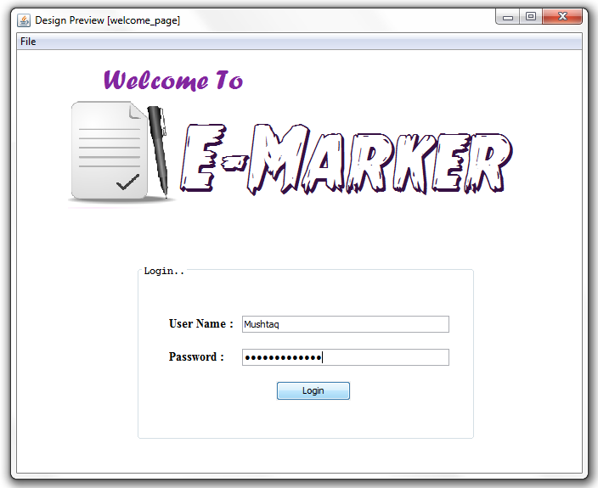

**Welcome screen :**

The start up page where the user name and password must be provided by the teacher to use E-marker application.

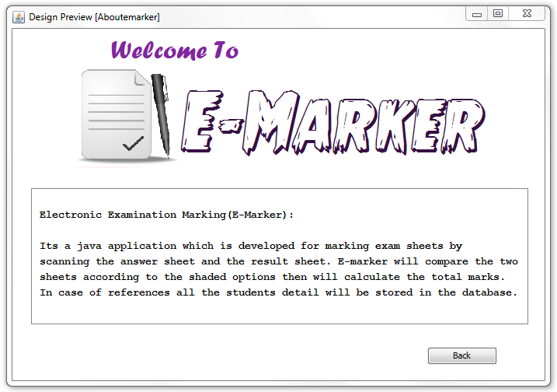**About E-marker screen:**

This page will hold brief information about E-marker application. User can open this page by clicking the file on menu bar and select About E-marker or by clicking the shortcut (Ctrl+A).

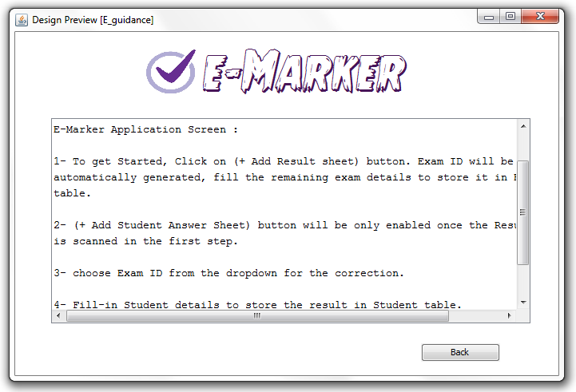

**Guidance Screen :**

E-marker provides the users to view the guidance of how to use E-marker application. User can click on file on the menu bar and select E-marker guidance to view this page or by pressing the shortcut (Ctrl+E).

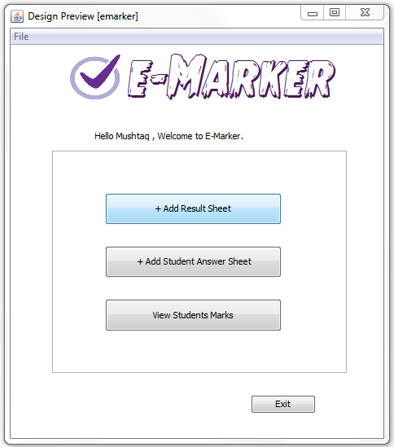

**E-Marker Application Screen:**

This page will provide the user with 3 main button. The first button will allow the user to scan result sheet. Users can add as many result sheets they want. Second button will allow the user to scan student answer sheet. The total mark will be stored in student database so once the third button is clicked E-marker will generate a table to show all students mark.

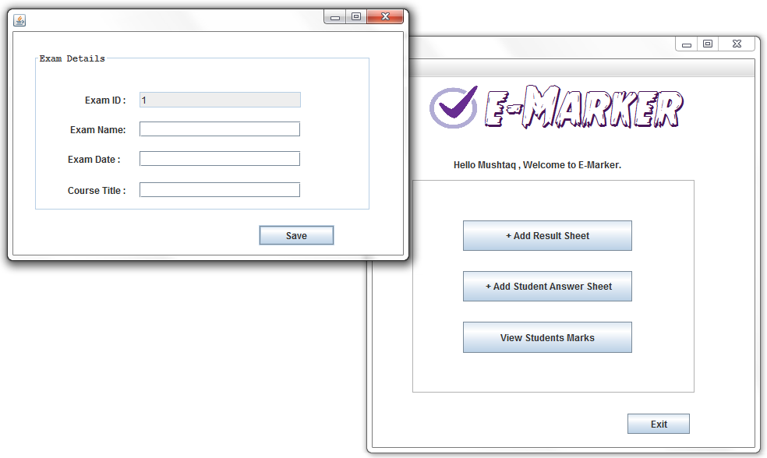

**Exam Details Screen:**

This page will pop up once the first button is clicked. E-marker will generate unique Exam IDs to be saved in exam’s table. User will fill-in the remaining exam details and will click save button.

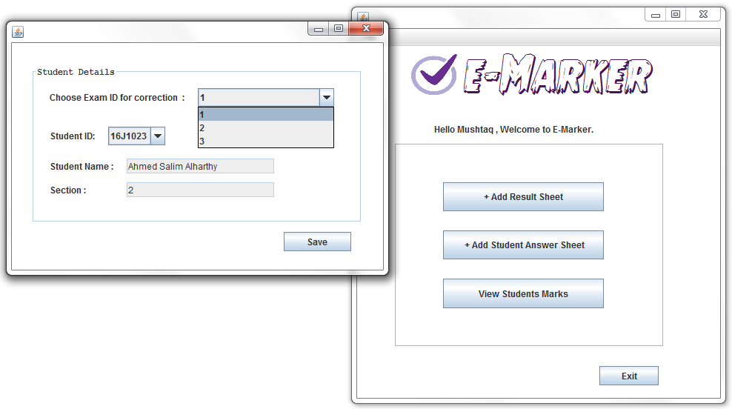

**Student details screen:**

(+ Add Student Answer Sheet) button won’t be enabled if there is no scanned result sheet. Once it’s enabled student details screen will pop up for the user to select the specific exam id for the correction. User will select student id from the dropdown list and the remaining details will be automatically retrieved from student table. Once the save button is clicked the comparison of two sheets will be processed and the total mark will be generated.